# Web Technologies And Mobile Programming



# #Lab Assignment-1:

# Name: Kaveti Manohar

# En.No: 2403A52079

BATCH:02

# QUESTION

E-Commerce Website Analysis:

OBJECTIVE: Use browser developer tools to analyze an e-commerce website’s network traffic, performance and Structure.

REQUIRMENTS: Create a simple e-commerce product page and analyze it using browser developer tools.

CODE

Screenshot-1

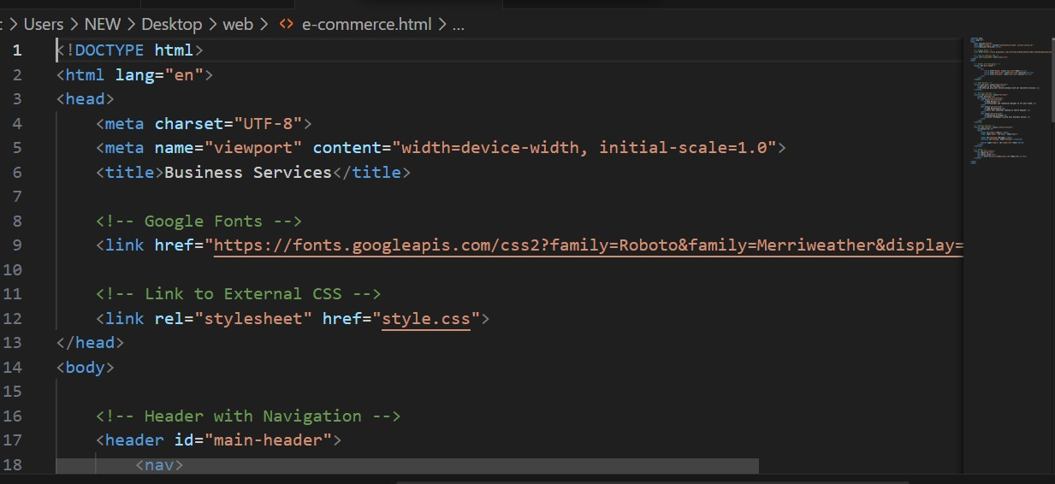

Screenshot-2

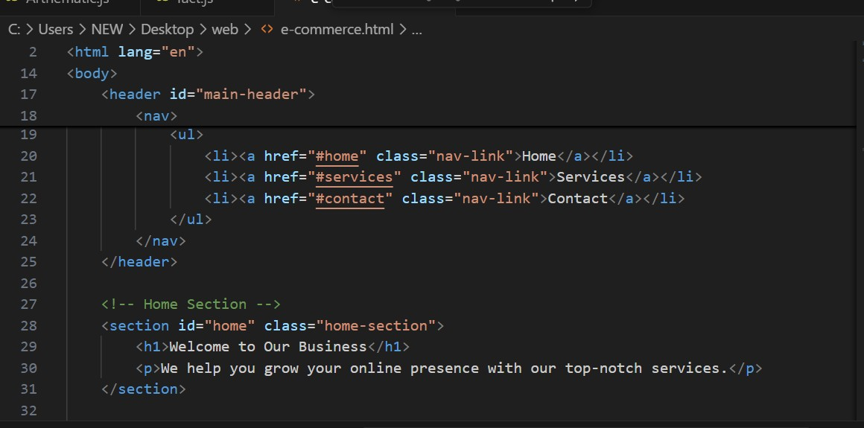

Screenshot-3

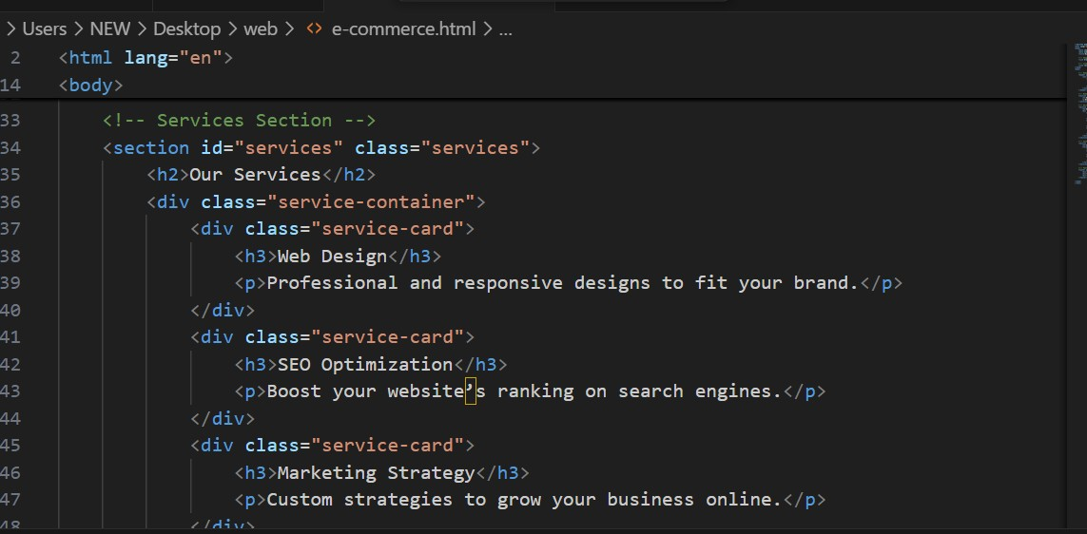

Screenshot-4

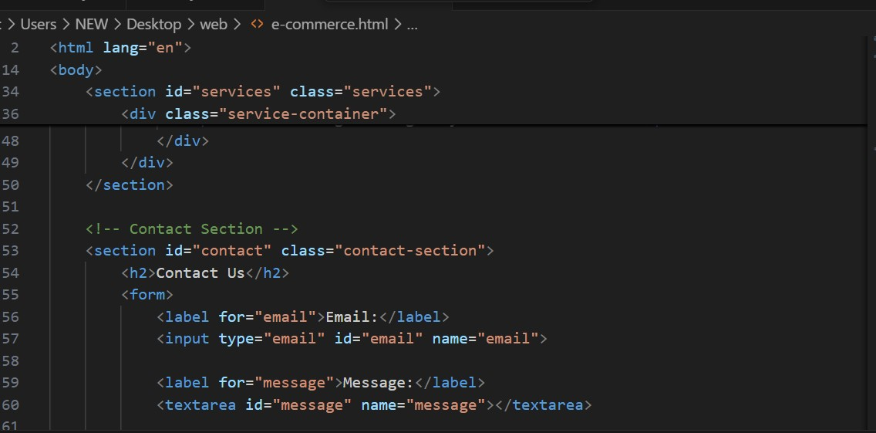

Screenshot-5

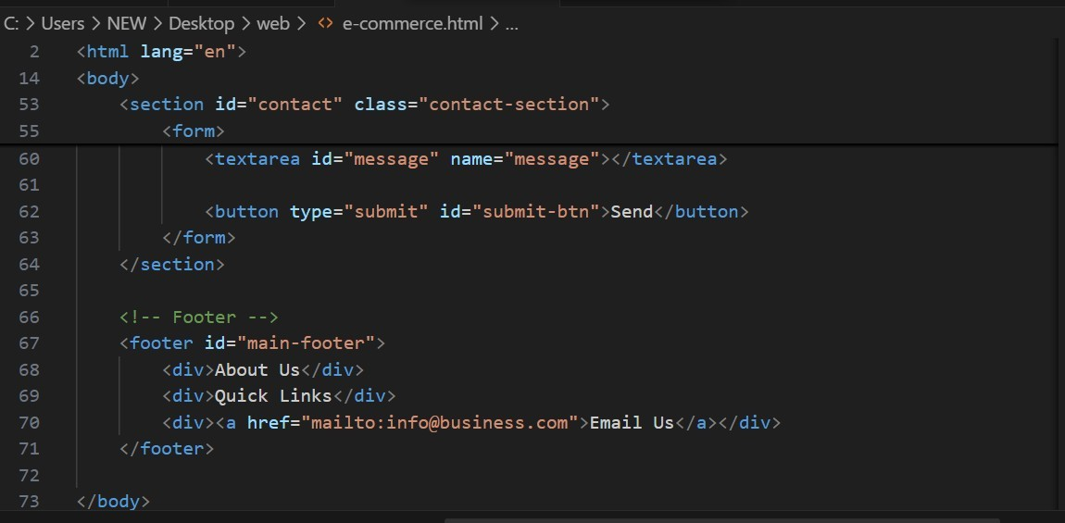

* After running this code successfully we get e-commerce web page.

OUTPUT

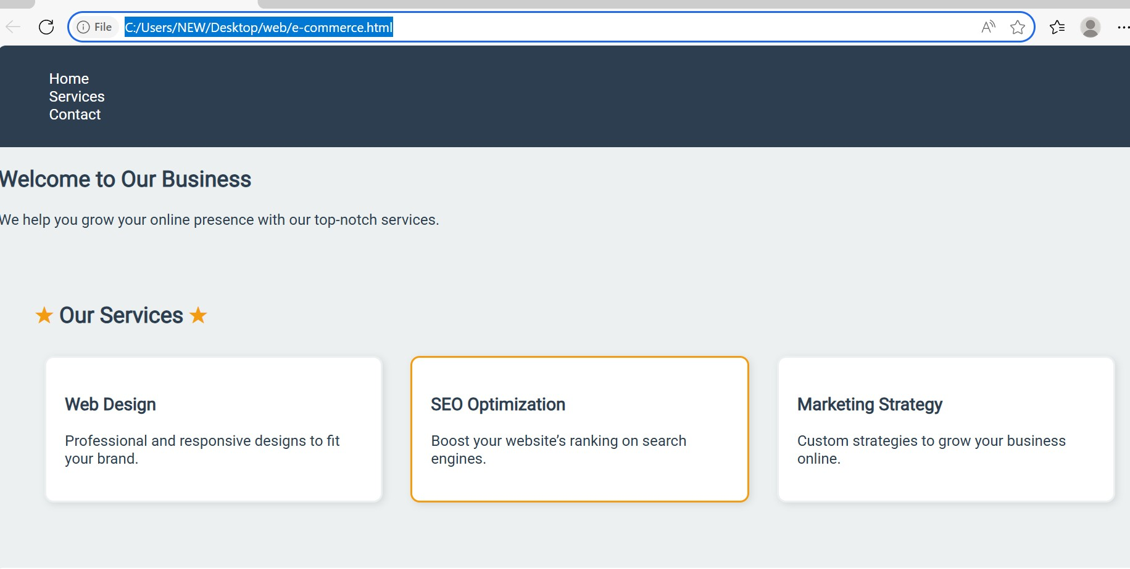

Screenshot-2



QUESTION-2

* HTML Tags
* CSS Style

S-1

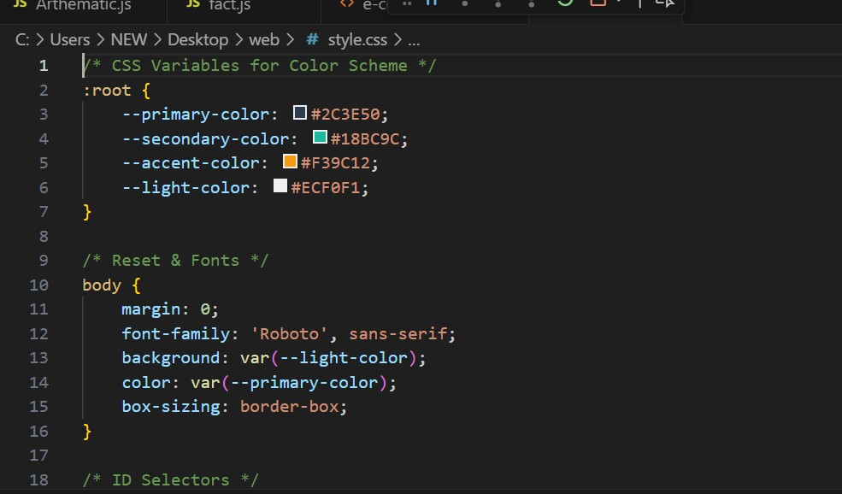

S-2

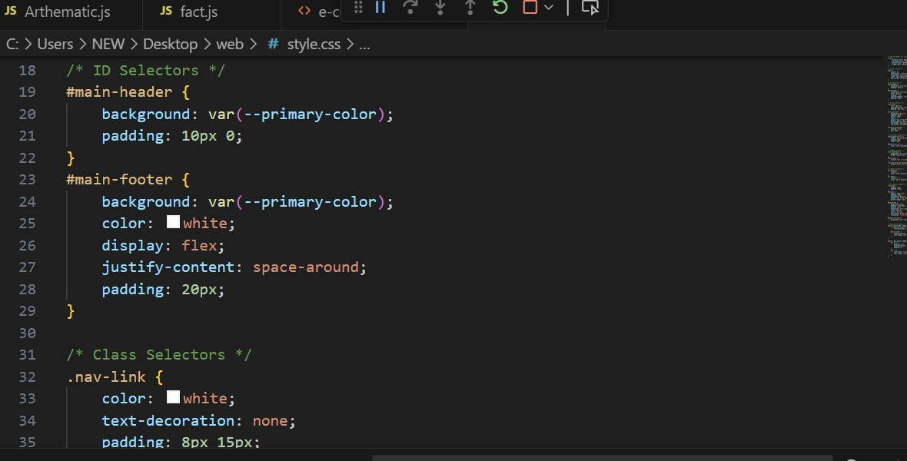

S-3

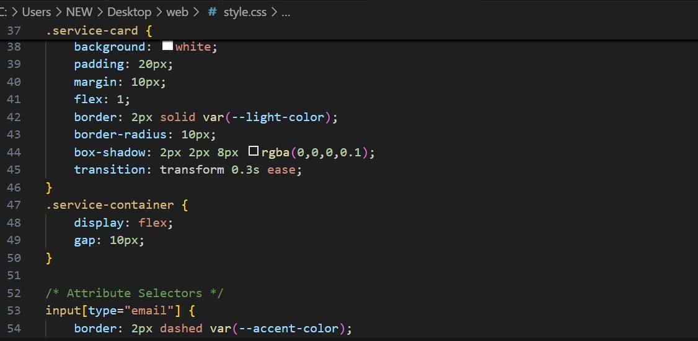

S-4

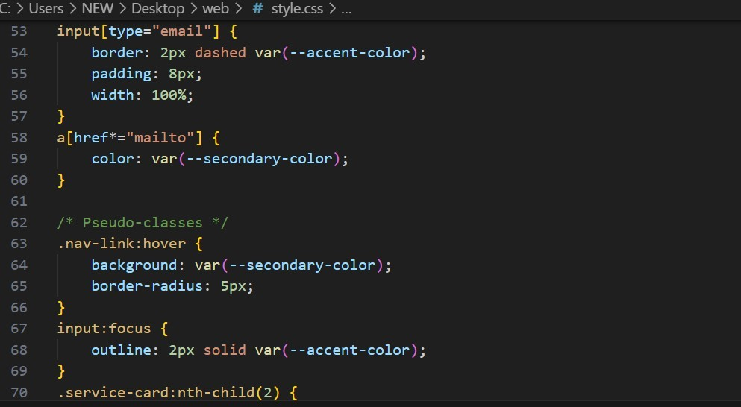

S-5

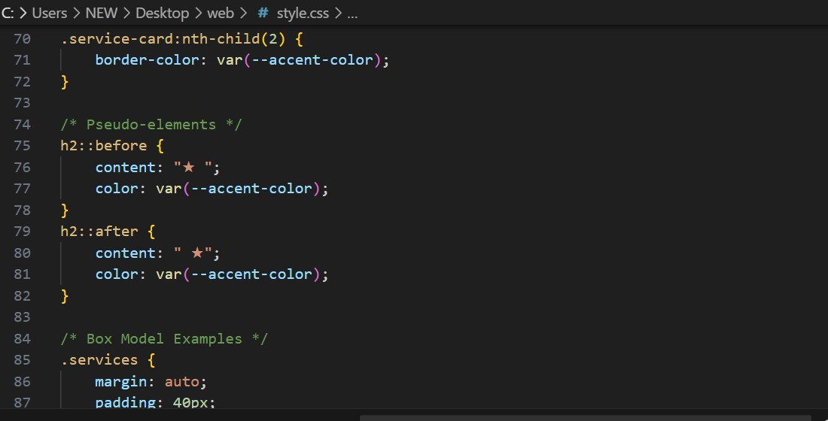

S-6

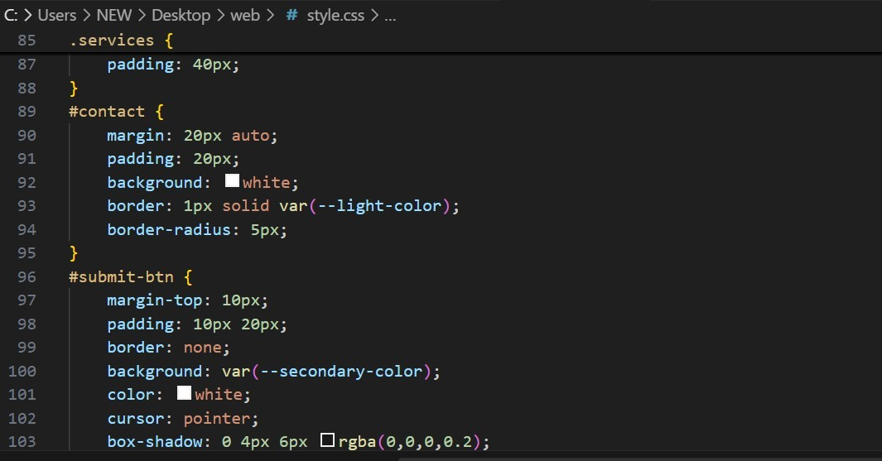

S-7

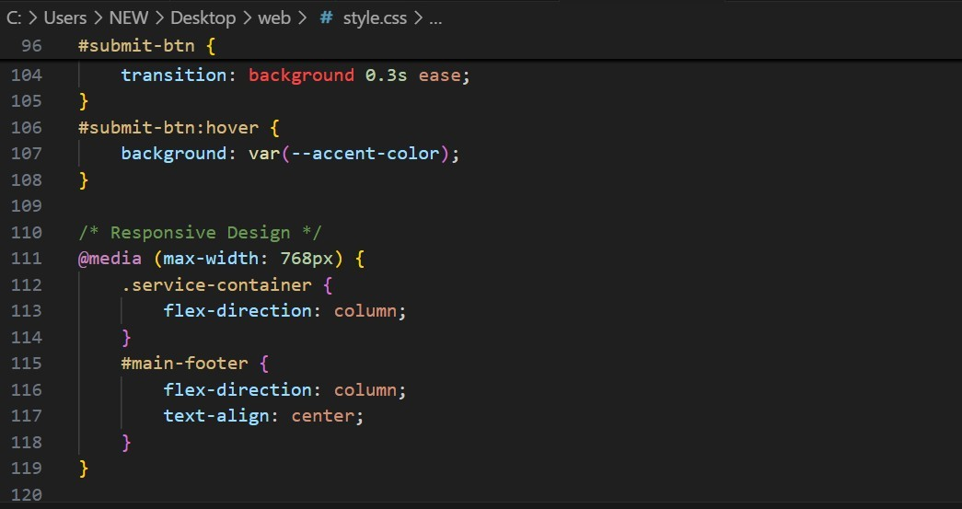

S-8

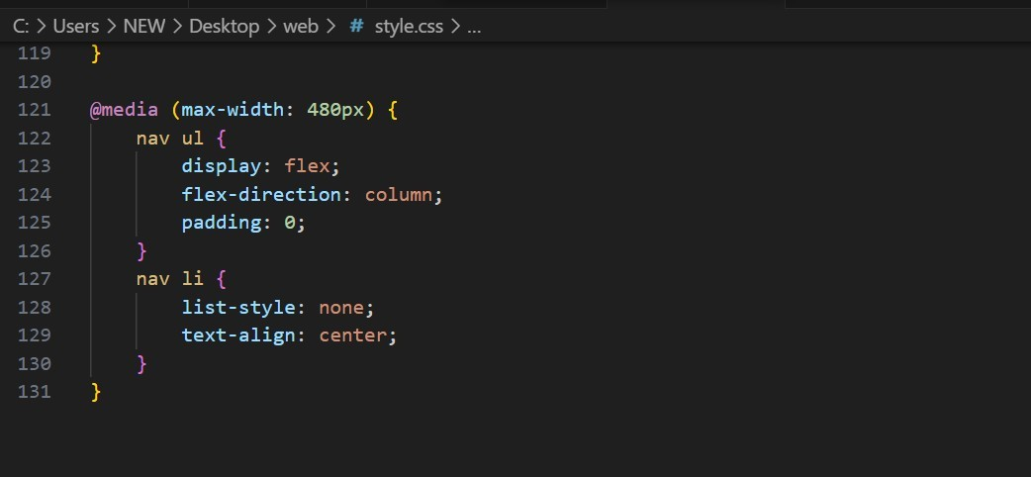

------------------------END------------------------